KONGNYUY RAYMOND AFONI FE21A219

**Implementing EMAILJS To my portfolio**

Introduction

EmailJS is a JavaScript library that allows you to send emails from your code. It is a free and open source library, and it supports a wide variety of email services.

To use EmailJS, you will need to create an account and get your API keys. Once you have your API keys, you can start sending emails.

To get started with EmailJS,

to install the library in project. command:

npm install emailjs

Once installed the library, you can start sending emails.Create account on emailjs and using GMAIL

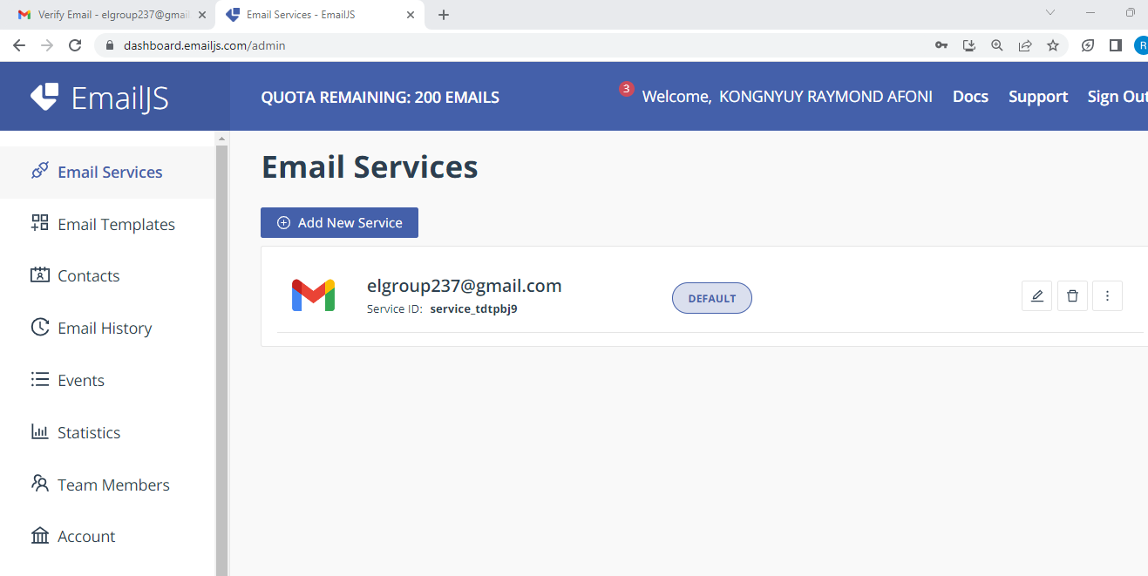 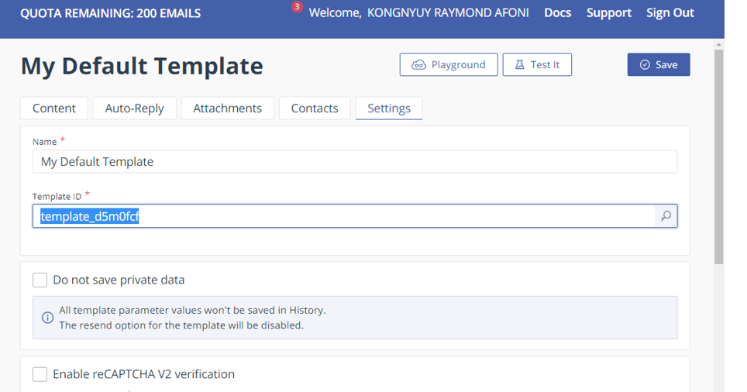 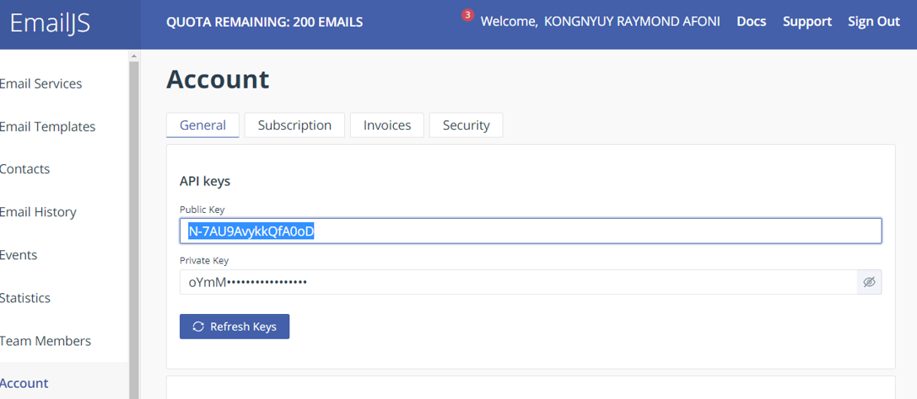

Sending Emails

To send an email using EmailJS, you will need to create a message object. The message object has the following properties:

* from: The sender's email address.
* to: The recipient's email address.
* subject: The subject of the email.
* text: The body of the email.
* html: The HTML body of the email.

Once you have created the message object, you can send the email using the following code:

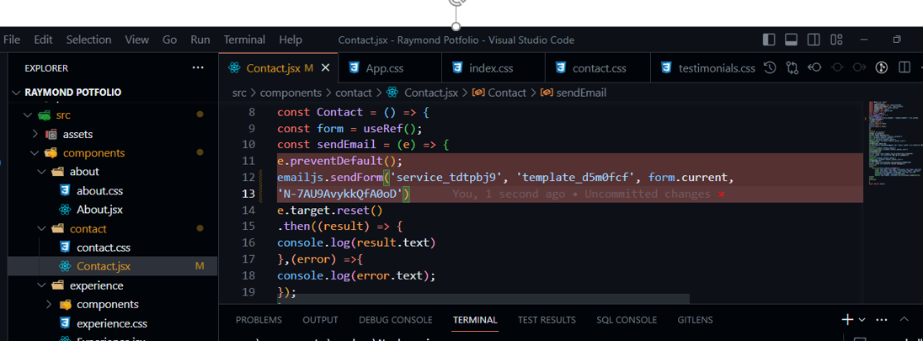

This code will send an email with the subject "This is a test email" and the body "This is the body of the email." to the recipient email address.

This code will send an HTML email with the subject "This is a test email" and the body "This is the body of the email." to the recipient email address.

Conclusion

EmailJS is a powerful tool that can be used to send emails from your code. It is a free and open source library, and it supports a wide variety of email services.